The managing director of the AEQT
visits the Ercros factory in Tortosa

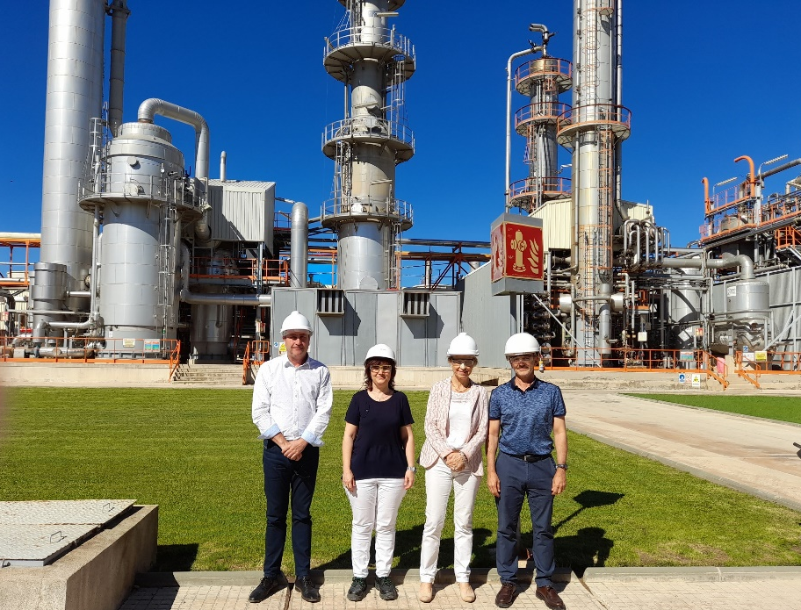
From left to right: Joan Miquel Capdevila, Teresa Camarasa, María Mas and Ángel Punzano.

The Ercros factory in Tortosa has received a visit from María Mas, managing director of the Chemical Business Association of Tarragona ("AEQT"). Ángel Punzano, director of the centre, and Teresa Camarasa, head of the R&D department of the intermediate chemicals division, have been in charge of receiving and accompanying Maria Mas on her visit to the factory.

Joan Miquel Capdevila, director of the Ercros industrial complex in Tarragona and president of the AEQT service companies commission, also joined the event.

The visit began with an explanation of the different production lines at the Tortosa factory and concluded with a tour at the centre’s facilities.

Tortosa, June 14, 2022

